3.2P: Answer Sheet
Recall task 2.2P Counter Class and answer the following questions.
- How many Counter objects were created?
Two Counter objects are created:

myCounters[0] → new Counter("Counter 1") myCounters[1] → new Counter("Counter 2")
myCounters[2] → points to the same object as myCounters[1], no new object created.

Variables declared without the new keyword are different to the objects created using new. In the Main function, what is the relationship between the variables initialized with and without the new keyword?
Variables created with new (myCounters[0], myCounters[1]) are new objects on the heap. myCounters[2] is just assigned the reference of myCounters[1], pointing to the same object.

So with new creates an object, without new just copies a reference to an existing object.

- In the Main function, explain why the statement myCounters[2].Reset(); also changes the value of myCounters[0].
In the Main function, the statement myCounters[2].Reset(); does not change the value of myCounters[0] because myCounters[0] and myCounters[2] refer to different Counter objects.

myCounters[0] points to a Counter object created with "Counter 1", while myCounters[2] is a reference to the same object as myCounters[1] ("Counter 2").

Therefore, calling Reset() on myCounters[2] only affects the Counter object assigned to myCounters[1] and myCounters[2], and does not affect myCounters[0].

- The difference between heap and stack is that heap holds “dynamically allocated memory.” What does this mean? In your answer, focus on the size and lifetime of the allocations.
Heap holds dynamic memory, meaning the memory for objects is allocated at runtime, not at compile time.
The size can be large, and objects exist until garbage collected (no longer referenced).

Are objects allocated on the heap or on the stack? What about local variables?
Objects (like Counter) are allocated on the heap.

Local variables (like myCounters) are stored on the stack and hold references to heap objects.

- What is the meaning of the expression new ClassName(), where ClassName

refers a class in your application? What is the value of this expression?
new ClassName() creates a new ClassName object on the heap. The value returned is a reference (pointer) to that object.

- Consider the statement “Counter myCounter;”. What is the value of
myCounter after this statement? Why?
After declaration, myCounter is null.
Because no object is created yet — it's just a reference without a target.

Based on the code you wrote in task 2.2P Counter Class, draw a diagram showing the locations of the variables and objects in function Main and their relationships to one another.

Stack | Heap
Main  …  myCounter(Counter[])-> | ref0 →  Counter { Name = "Counter 1", _count = 0 } ref1  → Counter { Name = "Counter 2", _count = 0 }

- If the variable myCounters is assigned to null, then you want to change the value of myCounters[X], where X is the last digit of your student ID, what will happen? Please provide your observation with screenshots and explaination.

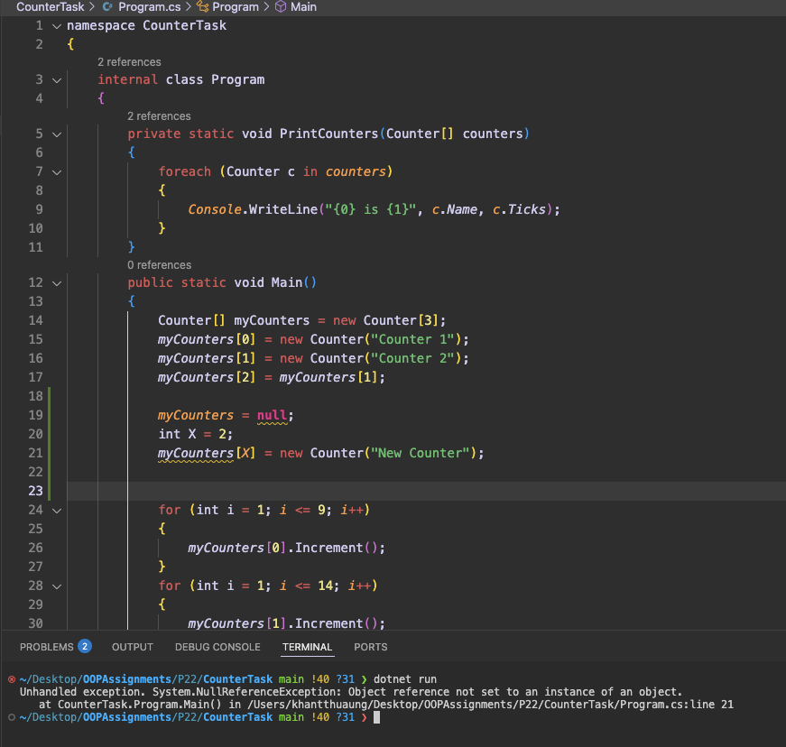

If myCounters is set to null, trying to access myCounters[X] will cause a NullReferenceException. This happens because myCounters no longer points to an array in memory. Since the reference is null, there is no object to access, and the program will crash when it tries to use it.

Hint. You may want to read this material for this task https://learn.microsoft.com/en-us/dotnet/csharp/language-reference/keywords/null

For further reading at your own.

CrowdStrike Blog, https://www.crowdstrike.com/blog/tech-analysis-channel-file-may- contain-null-bytes/
Null pointer CrowdStrike Bug, https://www.thestack.technology/crowstrike-null- pointer-blamed-rca/

